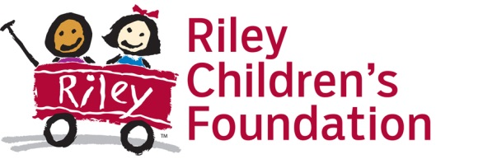
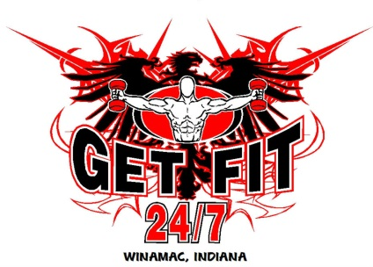
Get Fit NonStop’s 3rd Annual
Glow In The Park
5K Run/Walk
Saturday October 1st, 2016

My name is Chad Hammond and I’m the owner of Get Fit NonStop located in Winamac. We are planning our 3rd annual Glow in the Park run which will be held Saturday October 1st, 2016 in the Winamac Town Park. The run will start at dusk and will continue into the night. Glow in the dark items will be provided for the run. All profits from the run will be donated to the Riley Children’s Foundation. We are asking for your help by providing a donation, which will go a long way to helping us make this another successful event. Each year we receive approximately 200 runners/walkers for the event, which wouldn’t be possible without the donations that we receive.

Donation Information

With a donation of a $100 you or your company will get the following:
* Name on the back of the race T-Shirts
* Name announced before the race starts
* Name placed on our website and facebook page which has over 600 followers.

SPONSORSHIP CONTACT INFORMATION_____________________________________

Company_____________________________________________________________________________
Contact Name ________________________________________________________________________
Title ________________________________________________________________________________
Address ______________________________________________________________________________
City ________________________________________________State ____ Zip ____________________
Phone ( ) ____________________Email_______________________________________________

Please check here if you would like a receipt for your records _______

Checks are to be made to: Get Fit Nonstop

And sent to: Chad Hammond
470 E. Babcock LN
Rensselaer, IN 47978

Please send this form back to me no later than September 15th, so the items can be ordered. If you have any question please feel free to contact me at 219-863-1429 or by email Chammond1155@gmail.com

